|  |  |  |  |
| --- | --- | --- | --- |
| Pepino1 | 2 |  |  |
| Pepino2 | 3 |  |  |
| Pepino3 | 4 |  |  |
| Manzana mutante | 8 |  |  |
| Plátano mutante | 12 |  |  |
| Piña mutante | 20 |  |  |
| Patata mutante pequeño | 24 |  |  |
| Yuca mutante | 32 |  |  |
| Patata mutante Mediano | 36 |  |  |
| Piña de pino mutante | 44 |  |  |
| Maíz mutante | 100 |  |  |
| Carambola mutante | 200 |  |  |
| Zanahoria mutante | 300 |  |  |
| Patata mutante grande | 400 |  |  |
| Tuna mutante gigante | 500 |  |  |

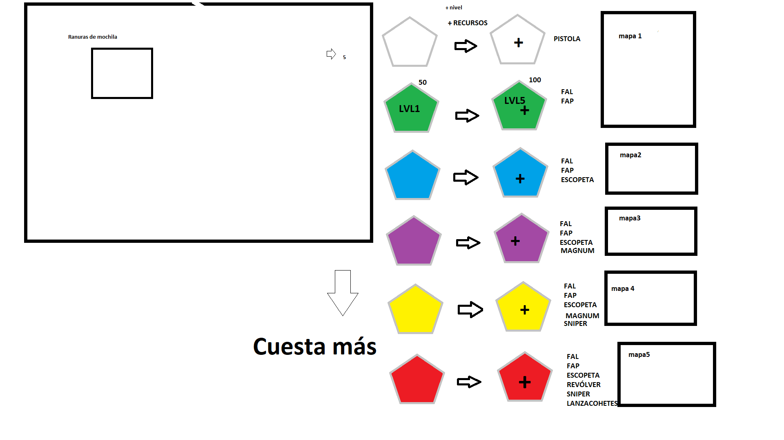

Pistola

|  |  |  |  |  |  |
| --- | --- | --- | --- | --- | --- |
| x = 1 ; x-- DOUBLE GUN ; x ++ | 1 | 2 | 3 | 4 | 3 DOUBLE GUN |
| r =10 ; 2*(r-10) ; r+=10 | 10 | 20 | 30 | 40 | 60 |

FAL 30

|  |  |  |  |  |  |
| --- | --- | --- | --- | --- | --- |
| x = 2 ; x-- DOUBLE GUN ; x ++ | 2 | 3 | 4 | 5 | 4 DOUBLE GUN |
| r =30 ; 2*(r-45) ; r+=45 | 30 | 75 | 120 | 165 | 240 |

|  |  |  |  |  |  |
| --- | --- | --- | --- | --- | --- |
| x = 4 ; x-- DOUBLE GUN ; x ++ | 4 | 5 | 6 | 7 | 6 DOUBLE GUN |
| r =120 ; 2*(r-10) ; r+=180 | 120 | 300 | 480 | 660 | 960 |

|  |  |  |  |  |  |
| --- | --- | --- | --- | --- | --- |
| x = 6 ; x-- DOUBLE GUN ; x ++ | 6 | 7 | 8 | 9 | 8 DOUBLE GUN |
| r =480 ; 2*(r-10) ; r+=720 | 480 | 1200 | 1920 | 2640 | 3840 |

|  |  |  |  |  |  |
| --- | --- | --- | --- | --- | --- |
| x = 8 ; x-- DOUBLE GUN ; x ++ | 8 | 9 | 10 | 11 | 10 DOUBLE GUN |
| r =1920 ; 2*(r-2880) ; r+=2880 | 1920 | 4800 | 7680 | 10560 | 15360 |

|  |  |  |  |  |  |
| --- | --- | --- | --- | --- | --- |
| x = 10 ; x-- DOUBLE GUN ; x ++ | 10 | 11 | 12 | 13 | 12 DOUBLE GUN |
| r =7680 ; 2*(r-11520) ; r+=11520 | 7680 | 19200 | 30720 | 42240 | 61440 |

FAP 50

|  |  |  |  |  |  |
| --- | --- | --- | --- | --- | --- |
| x = 3 ; x-- DOUBLE GUN ; x ++ | 3 | 4 | 5 | 6 | 5 DOUBLE GUN |
| r =30 ; 2*(r-45) ; r+=45 | 30 | 75 | 120 | 165 | 240 |

|  |  |  |  |  |  |
| --- | --- | --- | --- | --- | --- |
| x = 5 ; x-- DOUBLE GUN ; x ++ | 5 | 6 | 7 | 8 | 7 DOUBLE GUN |
| r =120 ; 2*(r-10) ; r+=180 | 120 | 300 | 480 | 660 | 960 |

|  |  |  |  |  |  |
| --- | --- | --- | --- | --- | --- |
| x = 7 ; x-- DOUBLE GUN ; x ++ | 7 | 8 | 9 | 10 | 9 DOUBLE GUN |
| r =480 ; 2*(r-10) ; r+=720 | 480 | 1200 | 1920 | 2640 | 3840 |

|  |  |  |  |  |  |
| --- | --- | --- | --- | --- | --- |
| x = 9 ; x-- DOUBLE GUN ; x ++ | 9 | 10 | 11 | 12 | 11 DOUBLE GUN |
| r =1920 ; 2*(r-2880) ; r+=2880 | 1920 | 4800 | 7680 | 10560 | 15360 |

|  |  |  |  |  |  |
| --- | --- | --- | --- | --- | --- |
| x = 10 ; x-- DOUBLE GUN ; x ++ | 11 | 12 | 13 | 14 | 13 DOUBLE GUN |
| r =7680 ; 2*(r-11520) ; r+=11520 | 7680 | 19200 | 30720 | 42240 | 61440 |

ESCOPETA 10*3

|  |  |  |  |  |  |
| --- | --- | --- | --- | --- | --- |
| x = 3 ; x-- DOUBLE GUN ; x ++ | 3 | 4 | 5 | 6 | 5 DOUBLE GUN |
| r =120 ; 2*(r-10) ; r+=180 | 120 | 300 | 480 | 660 | 960 |

|  |  |  |  |  |  |
| --- | --- | --- | --- | --- | --- |
| x = 7 ; x-- DOUBLE GUN ; x ++ | 5 | 6 | 7 | 8 | 7 DOUBLE GUN |
| r =480 ; 2*(r-10) ; r+=720 | 480 | 1200 | 1920 | 2640 | 3840 |

|  |  |  |  |  |  |
| --- | --- | --- | --- | --- | --- |
| x = 7 ; x-- DOUBLE GUN ; x ++ | 7 | 8 | 9 | 10 | 9 DOUBLE GUN |
| r =1920 ; 2*(r-2880) ; r+=2880 | 1920 | 4800 | 7680 | 10560 | 15360 |

|  |  |  |  |  |  |
| --- | --- | --- | --- | --- | --- |
| x = 9 ; x-- DOUBLE GUN ; x ++ | 9 | 10 | 11 | 12 | 11 DOUBLE GUN |
| r =7680 ; 2*(r-11520) ; r+=11520 | 7680 | 19200 | 30720 | 42240 | 61440 |

MAGNUM 9

|  |  |  |  |  |  |
| --- | --- | --- | --- | --- | --- |
| x = 5 ; x-=5 DOUBLE GUN ; x+=5 | 5 | 10 | 15 | 20 | 15 DOUBLE GUN |
| r =480 ; 2*(r-10) ; r+=720 | 480 | 1200 | 1920 | 2640 | 3840 |

|  |  |  |  |  |  |
| --- | --- | --- | --- | --- | --- |
| x = 15 ; x-=5 DOUBLE GUN ; x+=5 | 15 | 20 | 25 | 30 | 25 DOUBLE GUN |
| r =1920 ; 2*(r-2880) ; r+=2880 | 1920 | 4800 | 7680 | 10560 | 15360 |

|  |  |  |  |  |  |
| --- | --- | --- | --- | --- | --- |
| x = 25 ; x-=5 DOUBLE GUN ; x+=5 | 25 | 30 | 35 | 40 | 35 DOUBLE GUN |
| r =7680 ; 2*(r-11520) ; r+=11520 | 7680 | 19200 | 30720 | 42240 | 61440 |

FRANCOTIRADOR 7

https://learn.unrealengine.com/home/LearningPath/113226?r=False&ts=637324265159350407

|  |  |  |  |  |  |
| --- | --- | --- | --- | --- | --- |
| x = 15 ; x-=5 DOUBLE GUN ; x+=5 | 15 | 20 | 25 | 30 | 25 DOUBLE GUN |
| r =1920 ; 2*(r-2880) ; r+=2880 | 1920 | 4800 | 7680 | 10560 | 15360 |

|  |  |  |  |  |  |
| --- | --- | --- | --- | --- | --- |
| x = 25 ; x-=5 DOUBLE GUN ; x+=5 | 25 | 30 | 35 | 40 | 35 DOUBLE GUN |
| r =7680 ; 2*(r-11520) ; r+=11520 | 7680 | 19200 | 30720 | 42240 | 61440 |

RASHO 2

|  |  |  |  |  |  |
| --- | --- | --- | --- | --- | --- |
| x = 50;x-=100 DOUBLE GUN;x+=100 | 50 | 150 | 250 | 350 | 250 DOUBLE GUN |
| r =7680 ; 2*(r-11520) ; r+=11520 | 7680 | 19200 | 30720 | 42240 | 61440 |